Projectplace Launch Email 1
Subject: We’re rolling out Projectplace!
Hi [name],
We’re getting ready to launch a new project management software called Projectplace to [organization/department within the company]. Projectplace will make it easy for us to manage tasks related to projects, manage and share documents, and collaborate with everyone in one central place. It’s intuitive to use and you’ll be up and running in no time.
Here are three quick tasks you can do today to get started with Projectplace:
- Create your account. Use the activation email that you have received/will receive shortly to complete your user setup. Reply to this email if you need help, and your Projectplace administrator will be in touch.
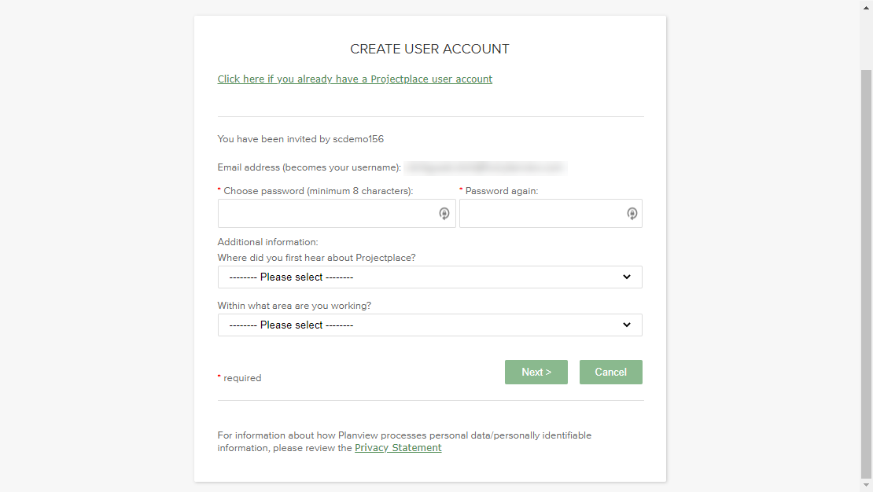
- Watch this 5-minute introductory video to learn more about Projectplace’s different tools and capabilities. There’s something for everyone!
[Embed Introducing Projectplace video here: https://success.planview.com/FLEX/Video_Introducing_Projectplace]
- Download Projectplace apps. There’s an easy-to-use mobile app so you can stay on top of all your projects while on the go, and a desktop documents app that allows you to work with documents stored in Projectplace directly on your computer.
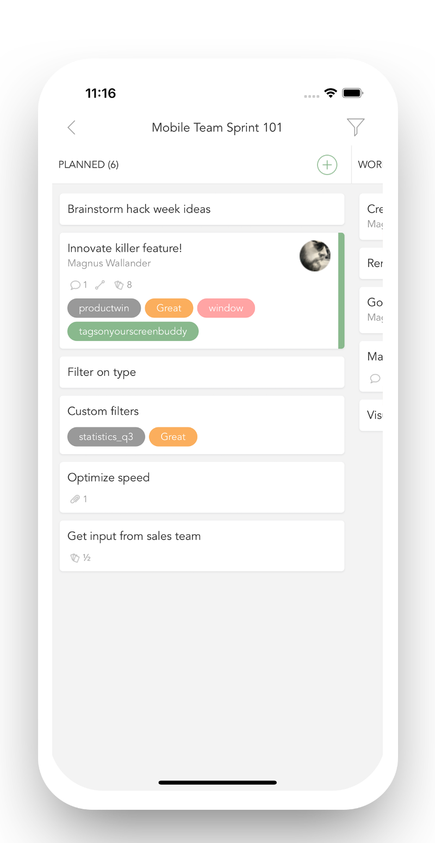

I’m looking forward to Projectplace making our collaboration and project execution run even more smoothly, and hope you are too. If you have any questions or need help, just reply to this email and your Projectplace administrator will be in touch.
Kind regards,
.......

Projectplace Launch Email 2
Subject: Start using Projectplace today
Hi [name],
Hopefully you’re a little more familiar with Projectplace and excited to get started working with your team! If you need a quick recap, here’s a short introductory video.
Ready to start? A good place to begin is visualizing your team’s current and planned work on a Kanban board. Click here to launch a guided tour on setting up and using your first Kanban board, or follow the steps below!
If you’re a project manager or team lead, you’ll start by creating a board. If you’re an individual team member, start by selecting a board from the dropdown menu.
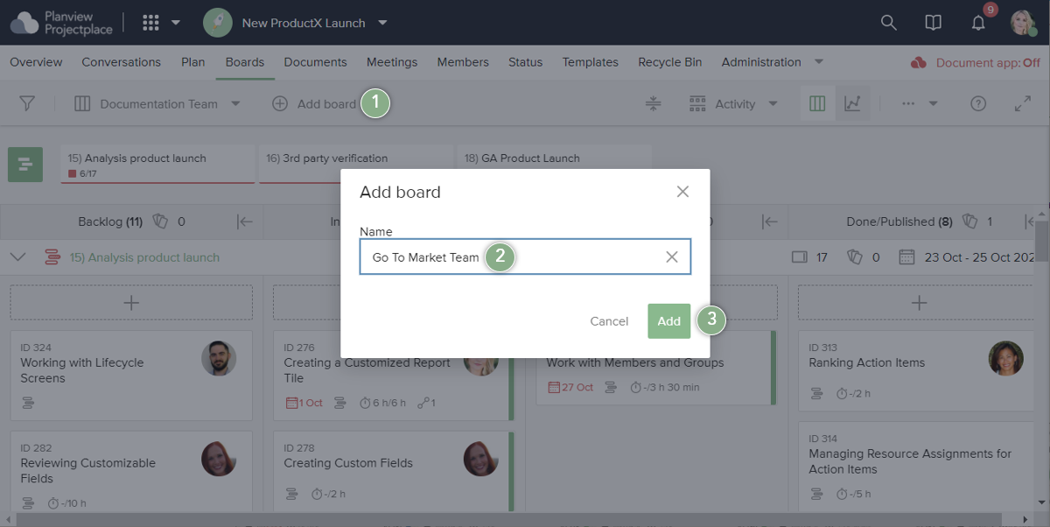
Tip: It’s easy to customize the default board design. To start, you might want to add and/or rename the board columns to align with the team’s workflow:
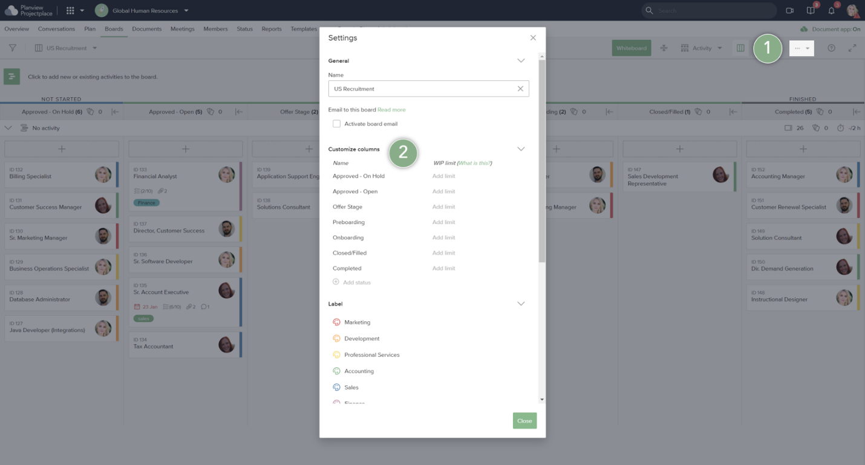
Next, create a few task cards. Cards are a great way to keep all information and communication about a task all in one place. As work progresses, cards move through the board’s status columns from left to right, keeping everyone on the team informed of the progress.
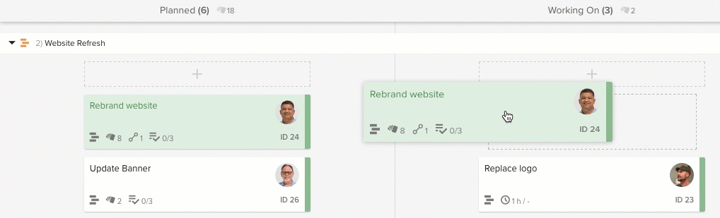
Need more help? Check out our Getting Started product help articles and our free Projectplace Fundamentals webinar.
Kind regards,
.......

Projectplace Launch Email 3
Subject: More Projectplace Tips and Tricks for You
Hi [name],
Now that you’ve been working with Projectplace for a while, check out these tips and tricks from Planview’s experts to get the most value out of Projectplace:

Keep track of your work
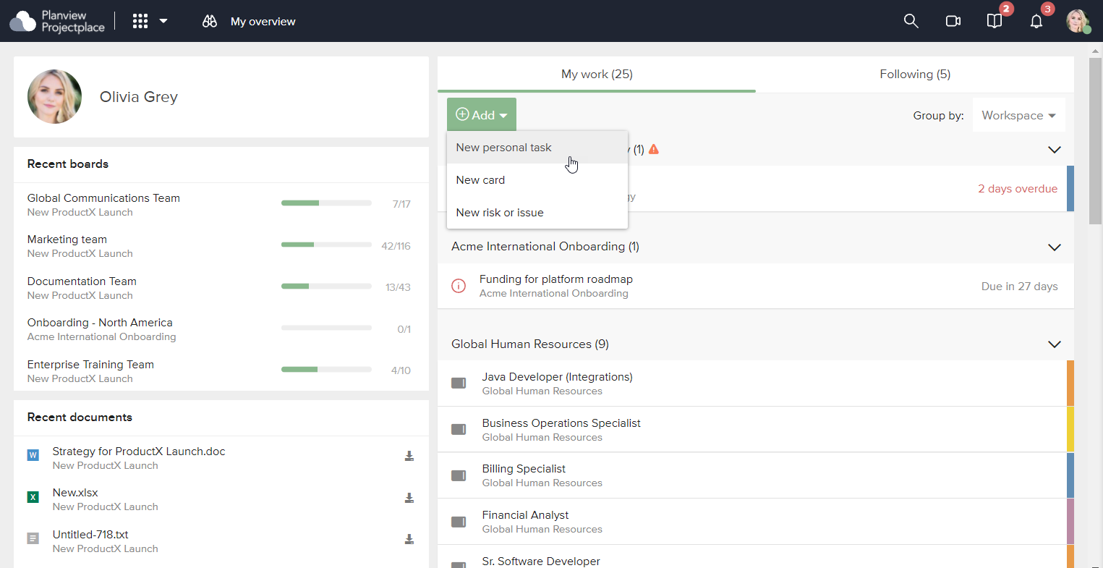
There are a variety of ways to keep track of and prioritize your work in Projectplace! You’ll always receive in-app and email notifications anytime someone assigns you to a card or document review, but another way to track your work is the My Overview page. It’s always the first screen you see when you sign in to Projectplace. Here you can find all the work that’s been assigned to you, and group your tasks by due date, workspace, or type of work. Learn more:
- Keep Track of All Your Tasks
- Keep Track of Your Personal Tasks
- Keep Track of Team Tasks

Save time with card and document templates
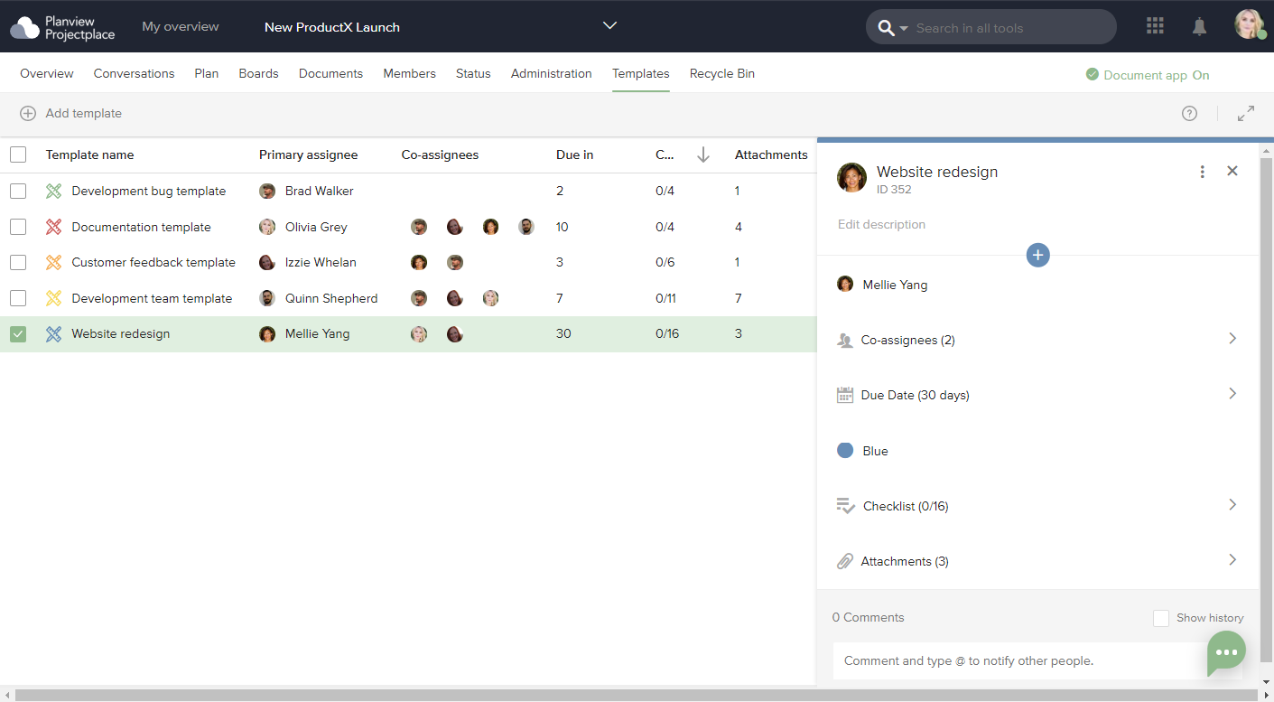
Document templates are useful when you need to adhere to specific processes and policies for a project, or want to save time when creating similar types of documents within a project. Similarly, you can use card templates to standardize repeatable tasks within a workspace, or just speed up the card creation process. Learn more:
- Webinar: Empower the Team with Templates
- Work with Document Templates
- Work with Document Review Templates
- Work with Card Templates

Connect activities to boards
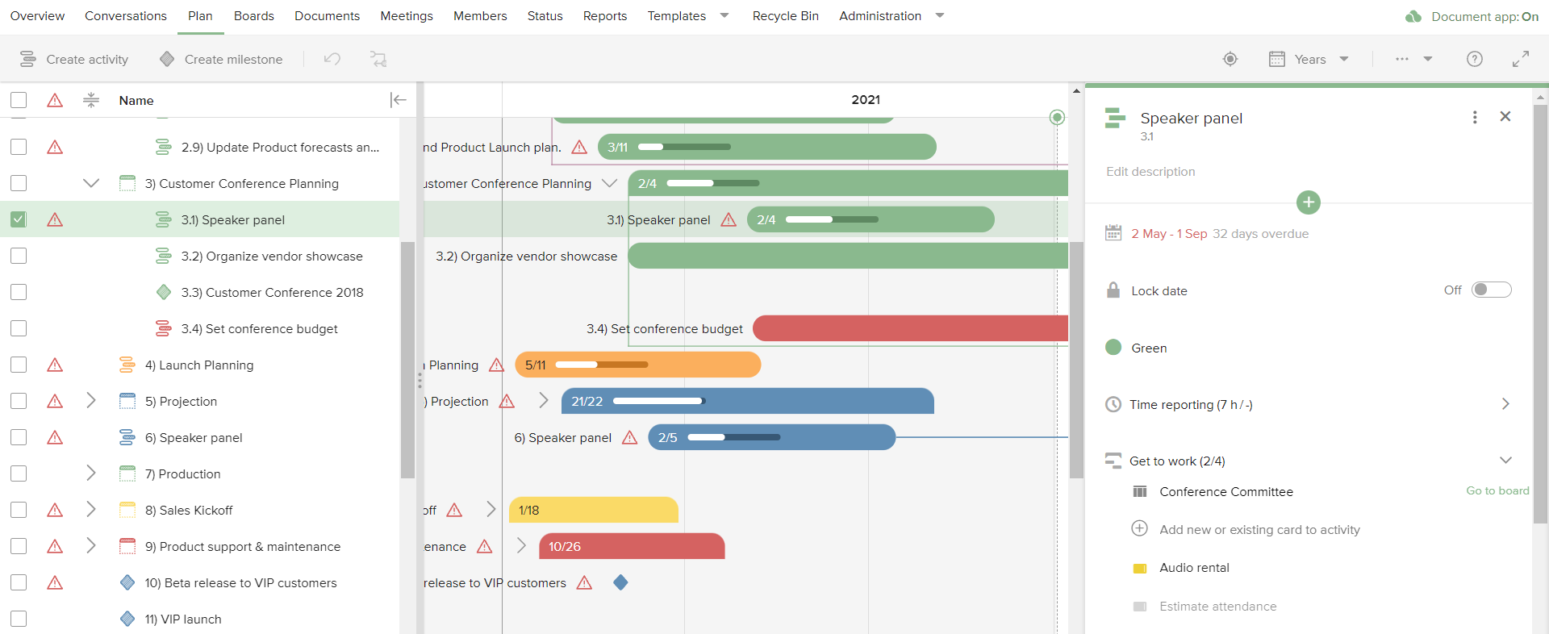
The connection between the Plan and Boards tools in Projectplace enables you to plan work, break work down into manageable tasks, and follow up on work progress in real-time. Each activity in the plan can be broken down into cards on boards, and as cards are moved to the Done column, activities in the Plan tool are updated to show the progress. Learn more:
- Add Activities and Milestones in the Plan Tool
- Break Down Activities
- Start Work on Activities
- Follow-up on Work Progress
If you’re looking for even more ways to use Projectplace, remember the Planview Customer Success Center has a full library of help content, instructional videos, and information about the latest product updates. Planview also offers monthly, free enablement webinars that you can sign up for to learn more tips and tricks.
Kind regards,
.......

