LeanKit Launch Email 1
Subject: We’re rolling out LeanKit!
Hi [name],
We’re getting ready to launch a new work management software called LeanKit to [organization/department within the company]. LeanKit supports lean and agile work delivery and will help us to easily prioritize, manage, and visualize the progress of our work using Kanban boards. LeanKit is very intuitive to use and you’ll be up and running in no time.
Here are three quick tasks you can do today to get started with LeanKit:
- Create your account. Use the activation email that you have received/will receive shortly to complete your user setup. Reply to this email if you need help, and your LeanKit administrator will be in touch.
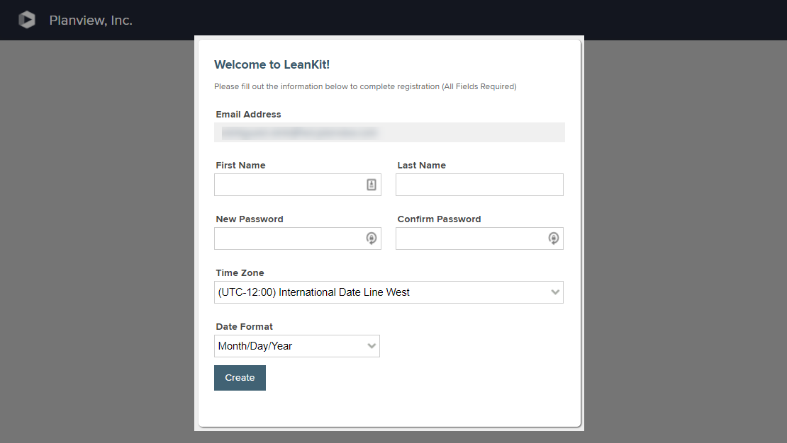
- Watch this 5-minute introductory video to learn more about LeanKit’s different capabilities. There’s something for everyone!
[Embed Introducing LeanKit video here: https://success.planview.com/FLEX/Video_Introducing_LeanKit] or we could link to it above.]
I’m looking forward to LeanKit helping us to manage work even more efficiently, and hope you are too. If you have any questions or need help, just reply to this email and your LeanKit administrator will be in touch.
Kind regards,
.......

LeanKit Launch Email 2
Subject: Start using LeanKit today
Hi [name],
Hopefully you’re a little more familiar with LeanKit and excited to get started working with your team! If you need a quick recap, here’s a short introductory video.
Ready to start? A good place to begin is visualizing your team’s current and planned work on a Kanban board. If you’re a team lead or a scrum master, you’ll start by creating a board. Individual team members can start by selecting a board from the LeanKit home screen.
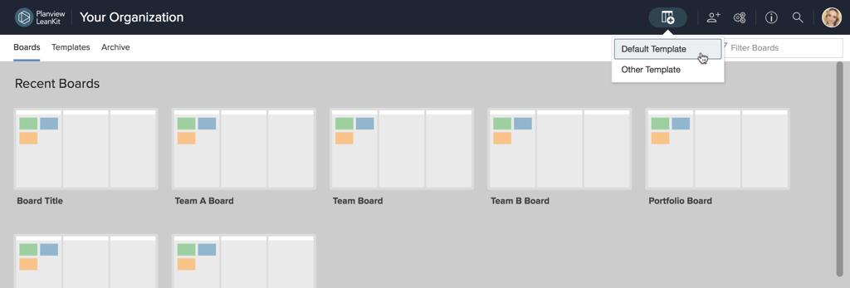
Next, create a few task cards to visualize your work on the board. Cards are a great way to keep all information and communication about a task all in one place. As work progresses, cards move through the board’s lanes from left to right, keeping everyone on the team informed of the progress and priority of work items.
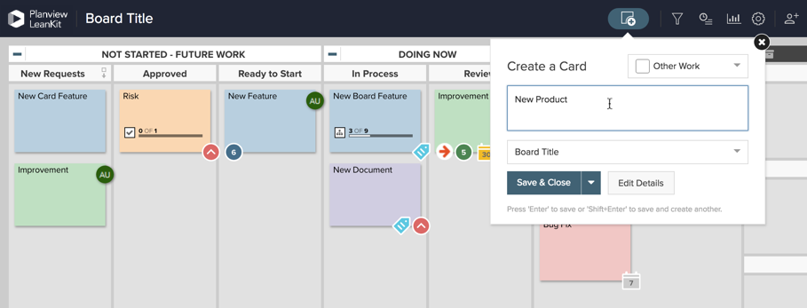
Tip: Cards can be as simple or detailed as you like. Here’s an example of some basic information to include on a card:
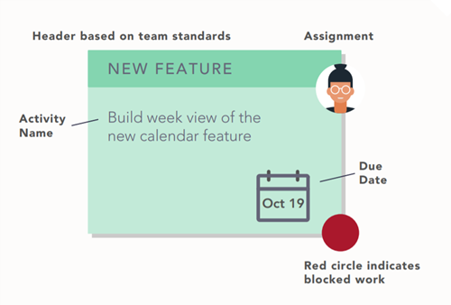
Finally, start using the board as soon as possible! Many teams hold weekly planning and standup meetings, using the board as a tool for prioritizing their work, removing blockers, and tracking important metrics to gain valuable insights about the team’s efficiency.
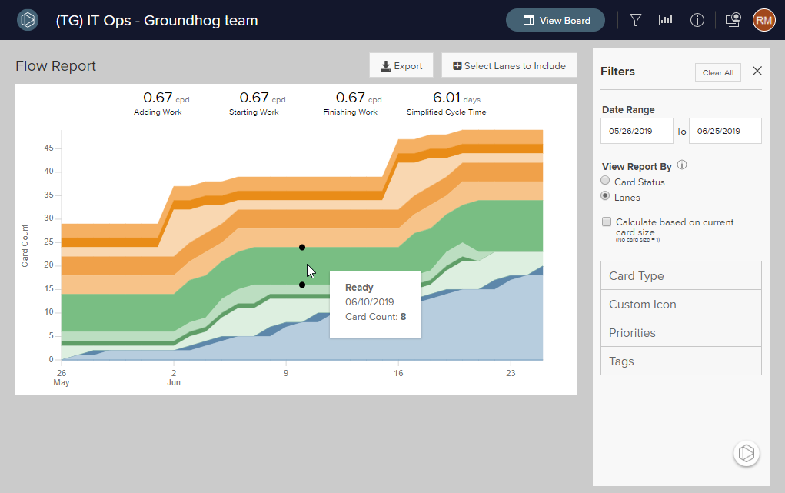
Need more help? Check out our Getting Started product help articles and our free LeanKit Fundamentals webinar.
Kind regards,
.......

LeanKit Launch Email 3
Subject: More LeanKit Tips and Tricks for You
Hi [name],
Now that you’ve been working with LeanKit for a while, check out these tips and tricks from Planview’s experts to get the most value out of LeanKit:

Get Ideas Brewing with Instant Coffee
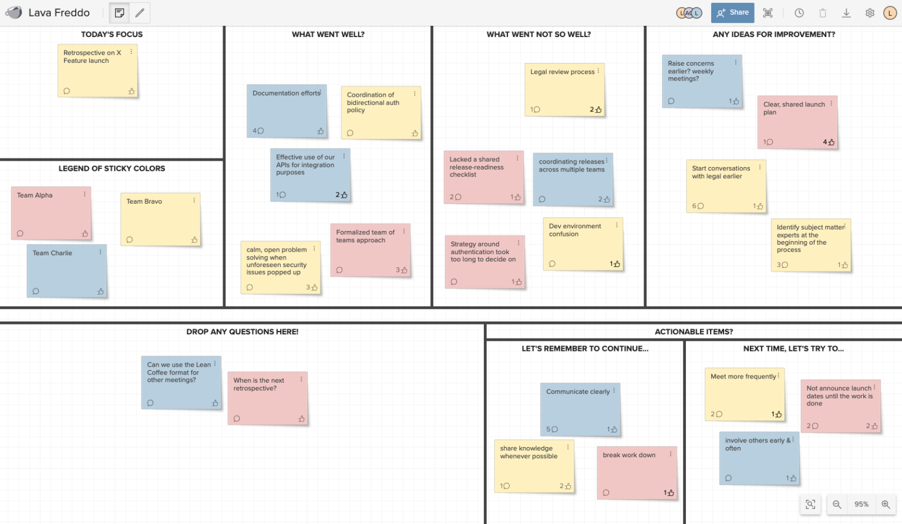
Instant Coffee enables teams to brainstorm and collaborate in real time using virtual sticky notes. Use your virtual canvas to sort ideas and determine which ideas are prime for execution, then keep the buzz going by transferring stickies to your LeanKit board as cards to take action on!
Keep this versatile tool in mind next time you need to brainstorm, plan, or collaborate with others. And for more ideas about ways to use Instant Coffee, we recommend watching this 15 minute demo for inspiration.

Get creative with your board design
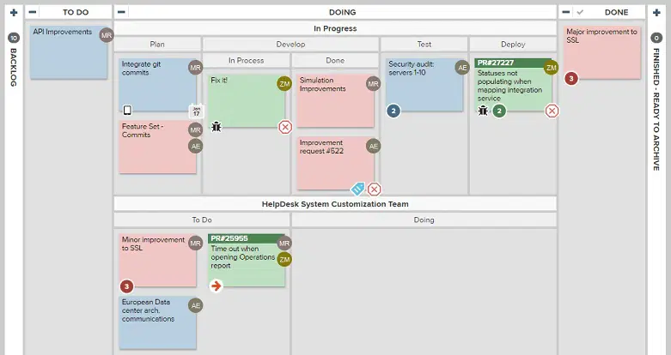
Edit your board’s layout to change the default To Do, Doing, and Done lanes on the board to mirror your team’s unique process. You don’t have to worry about designing the “perfect” board, but capturing critical points in your process (such as where handoffs occur) will help you refine your process.
Download our free Process Design Worksheets to get step-by-step guidance on designing your board layout and testing your process:
- Process Design Worksheet Part 1
- Process Design Worksheet Part 2
If you’re looking for even more ways to use LeanKit, remember the Planview Customer Success Center has a full library of help content, instructional videos, and information about the latest product updates. Planview also offers free webinars that you can sign up for to learn more tips and tricks.
Kind regards,
.......

